ASSIGNMENT – 14.4
NAME: Nallala siri
HT.NO: 2403A52037
BATCH: AIB03
Task-1
Prompt:
Generate a responsive web page with header, main content, footer, an interactive alert button, and a validated contact form.
Code:
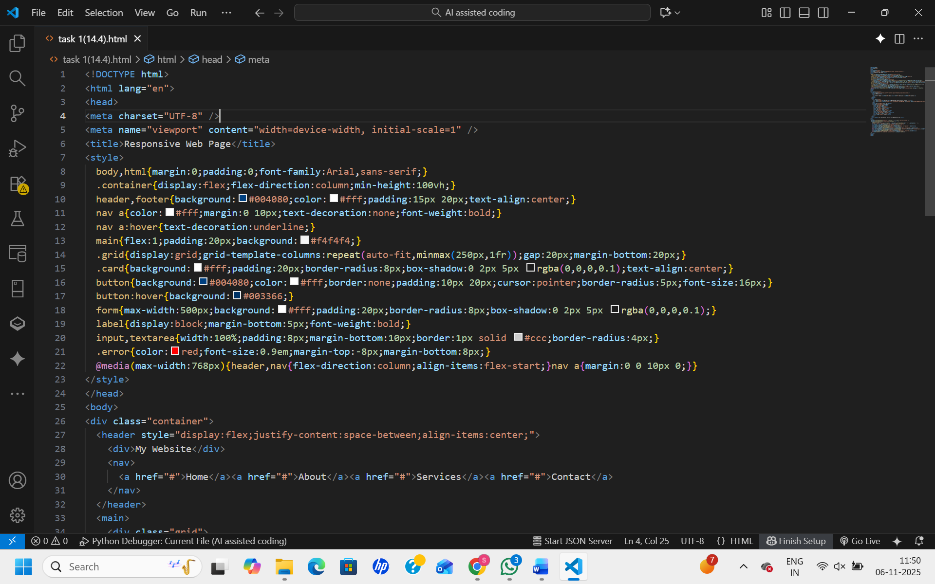

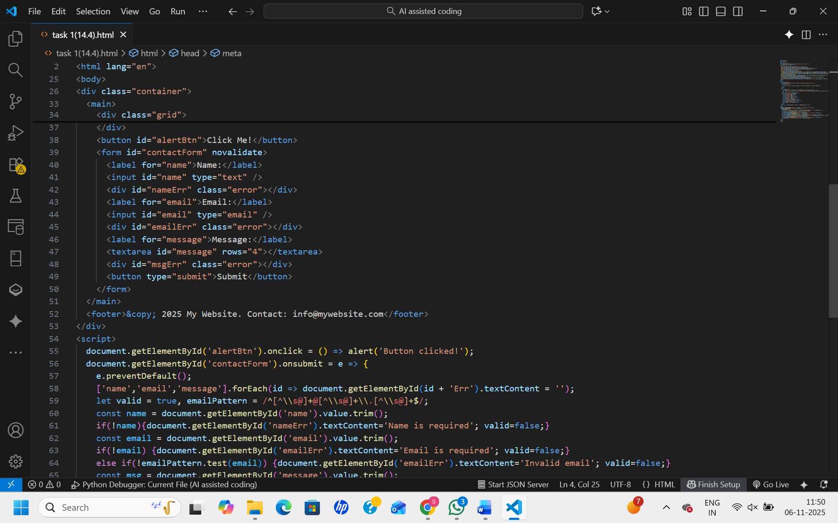

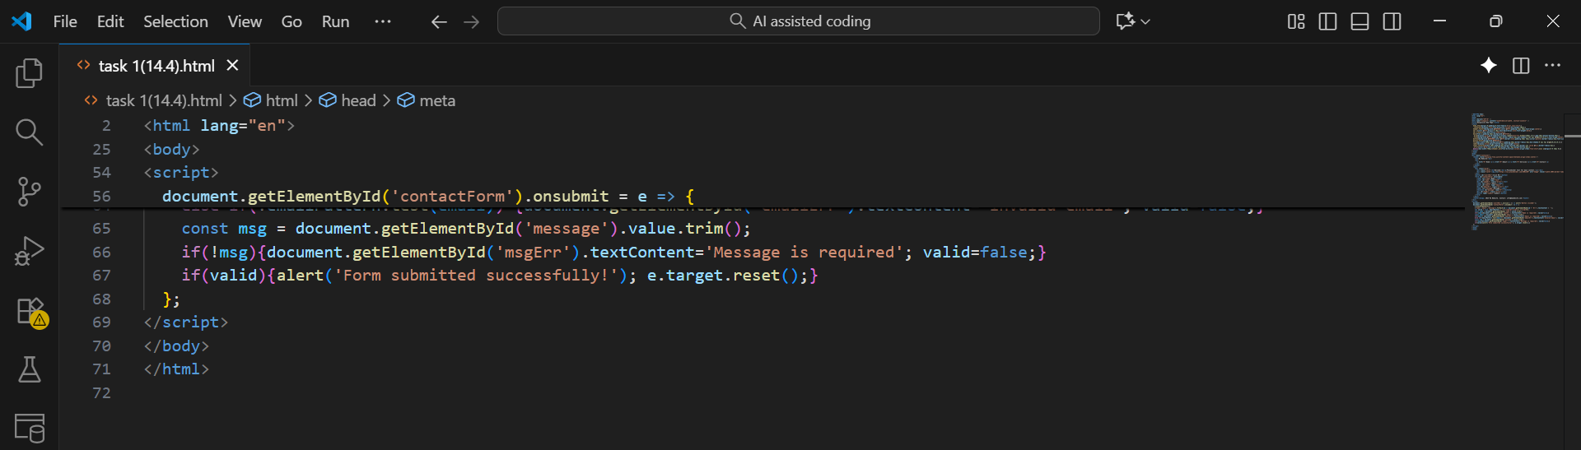
OUTPUT:

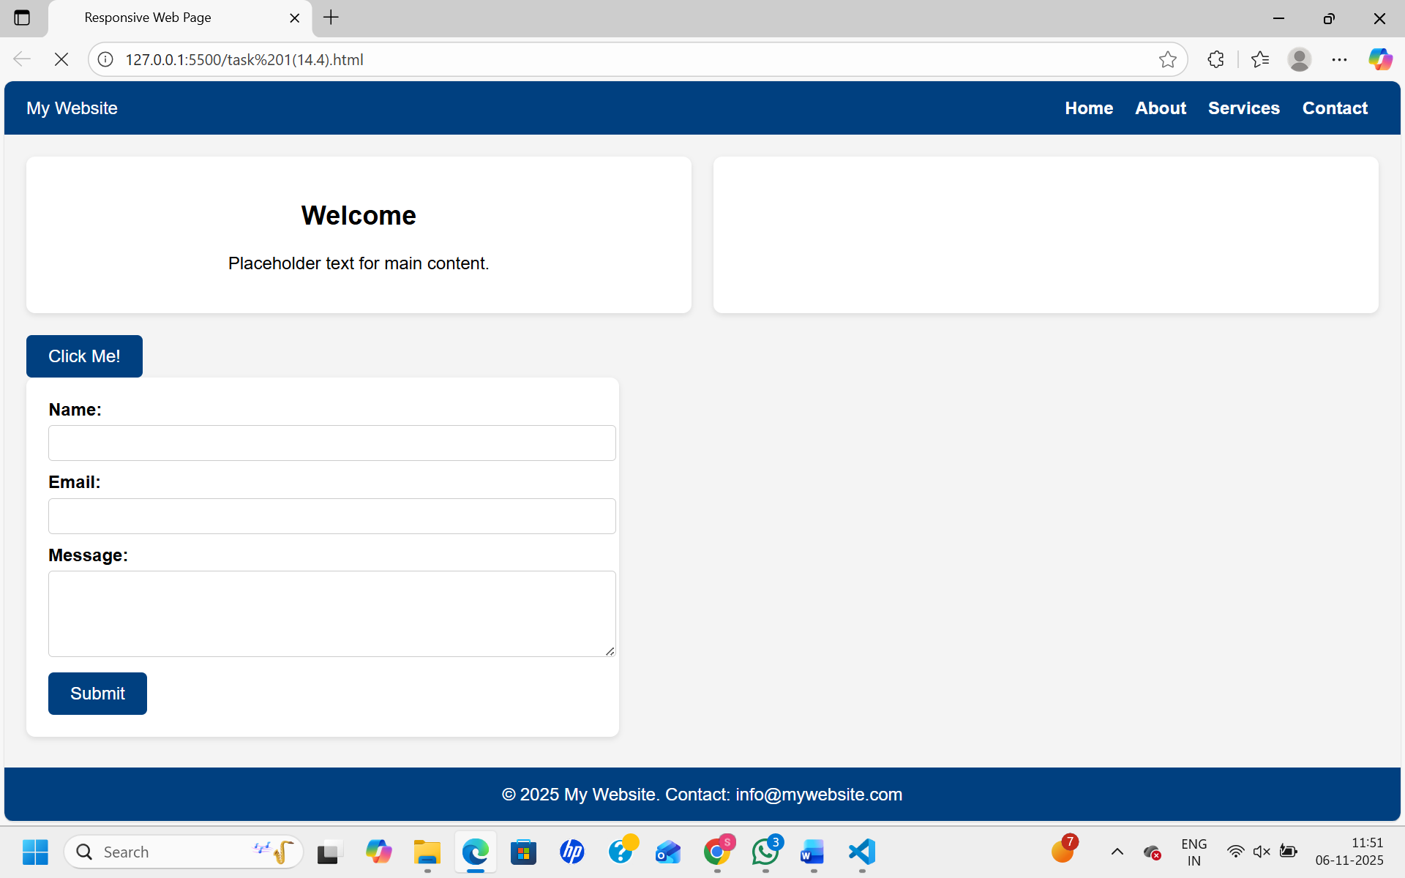
Observation:
The code builds a responsive web page with a header, main content, and footer that adjusts smoothly to different devices. The button offers an interactive alert message on click. The contact form validates user input and highlights errors inline for a better experience. The design is simple, clean, and user-friendly.
Task-2
Prompt:
Create a web page with a button that shows an alert message when clicked using clean and commented JavaScript code.
Code:

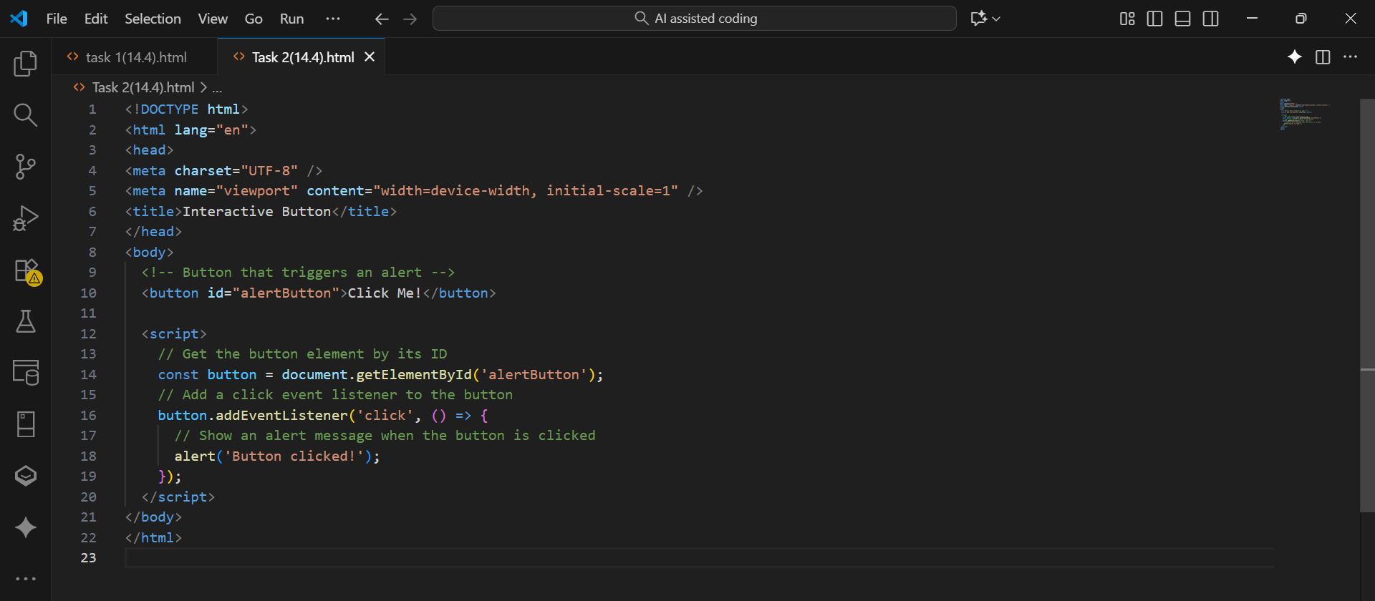
OUTPUT:

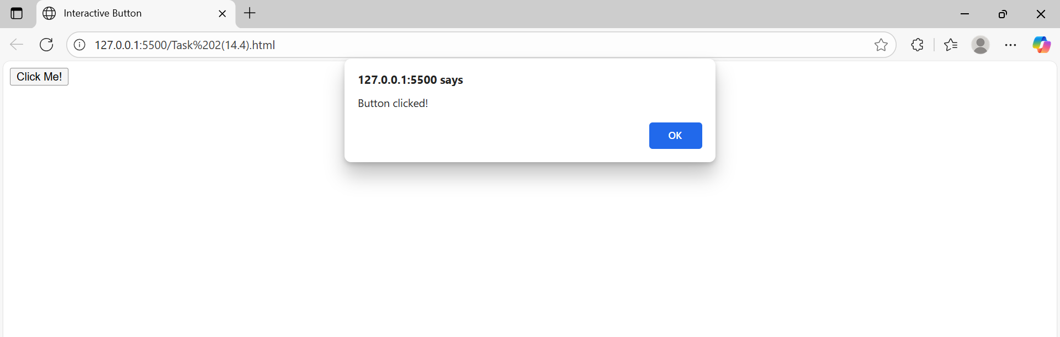
Observation:
The code creates a simple web page with a button labeled "Click Me!". When the button is clicked, a JavaScript alert box with the message "Button clicked!" appears. The JavaScript is cleanly written and well-commented for easy understanding. This code effectively demonstrates how to add interactivity using event listeners in JavaScript.
Task-3:
Prompt:
Create a contact form with Name, Email, Message fields validating non-empty inputs and correct email format, showing inline errors and success alert.
Code:

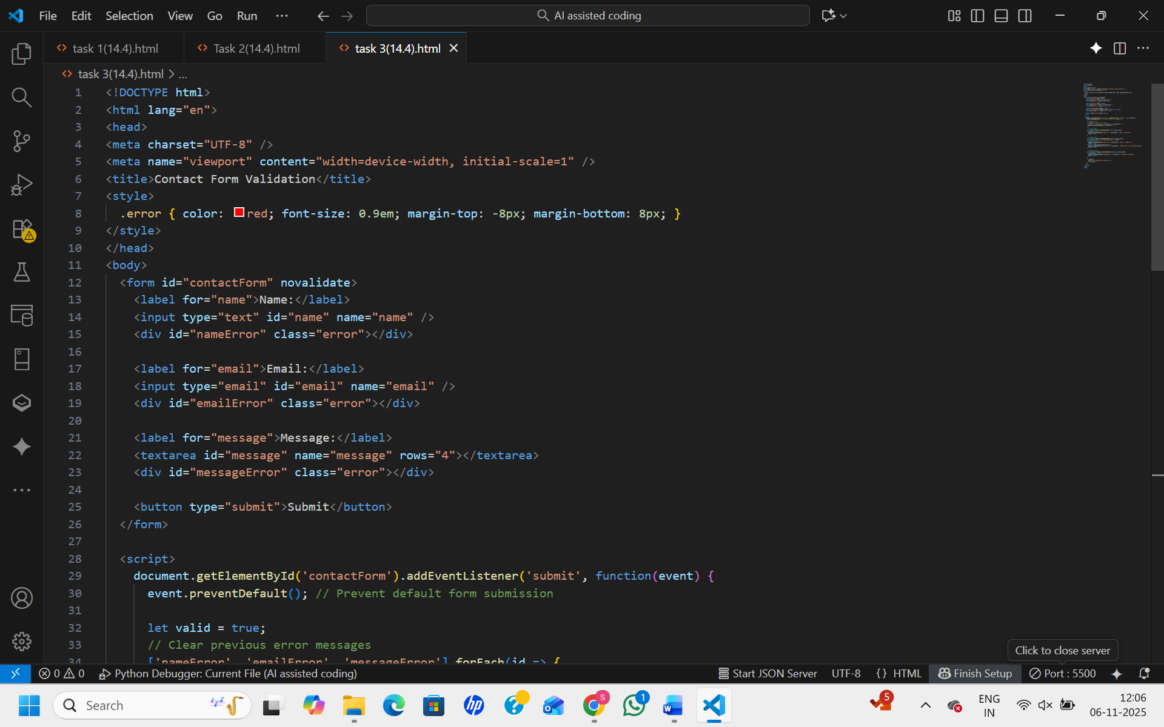

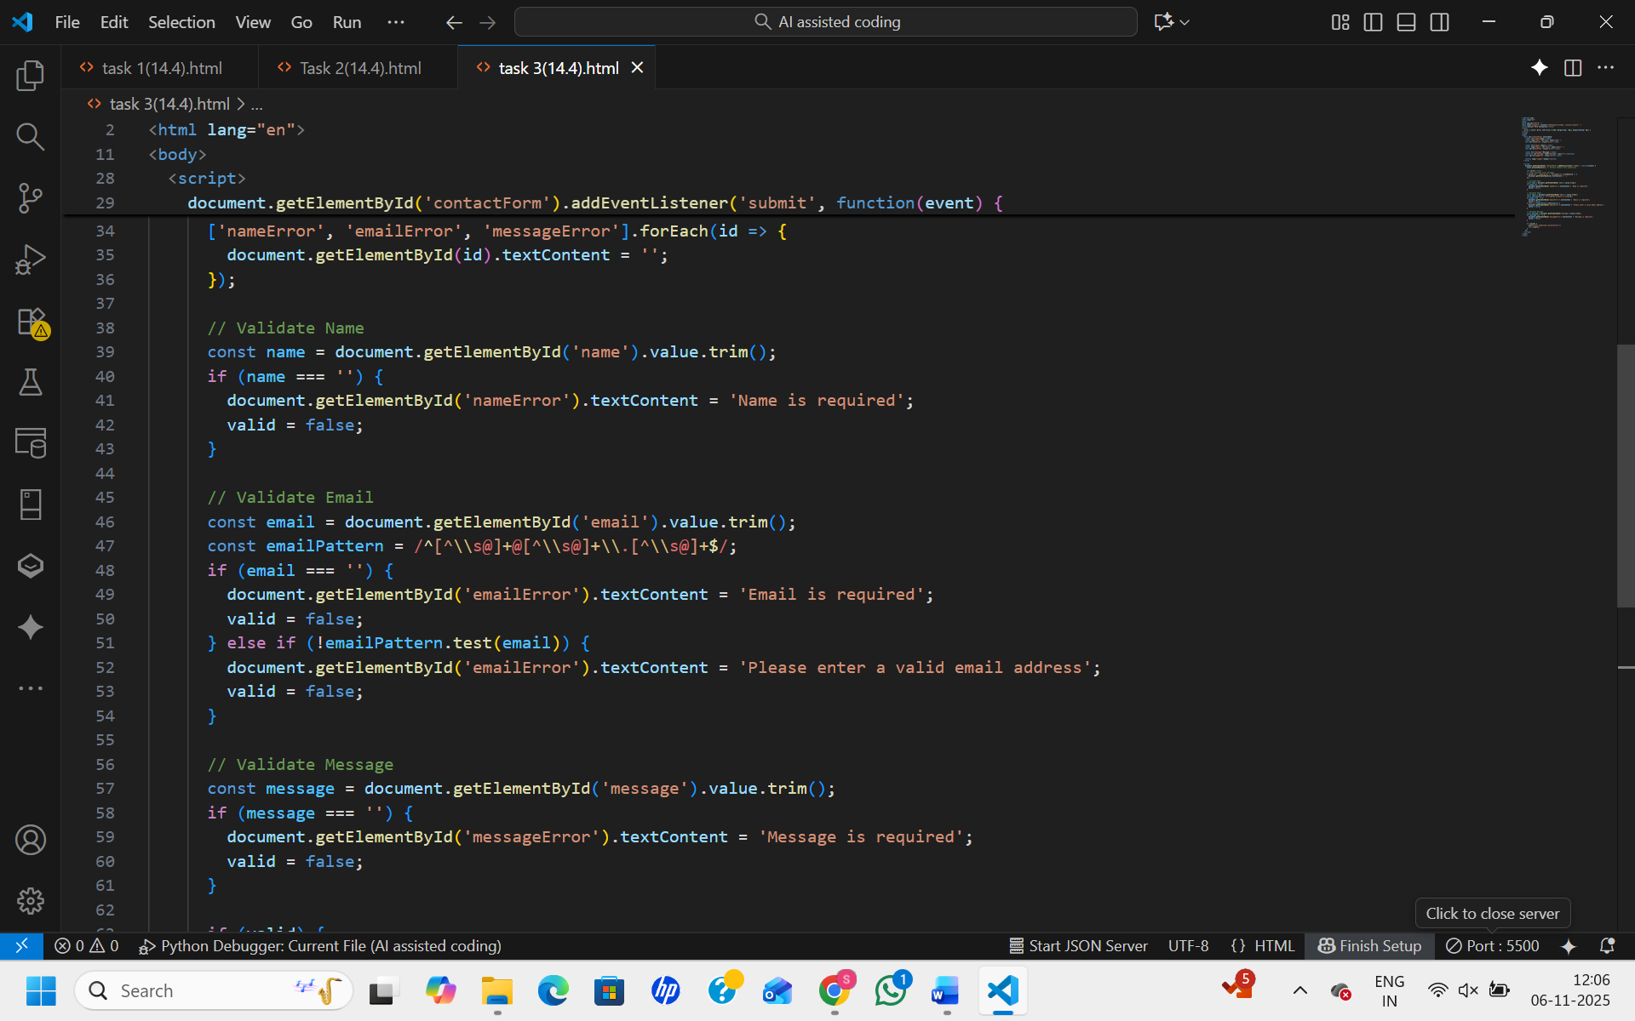

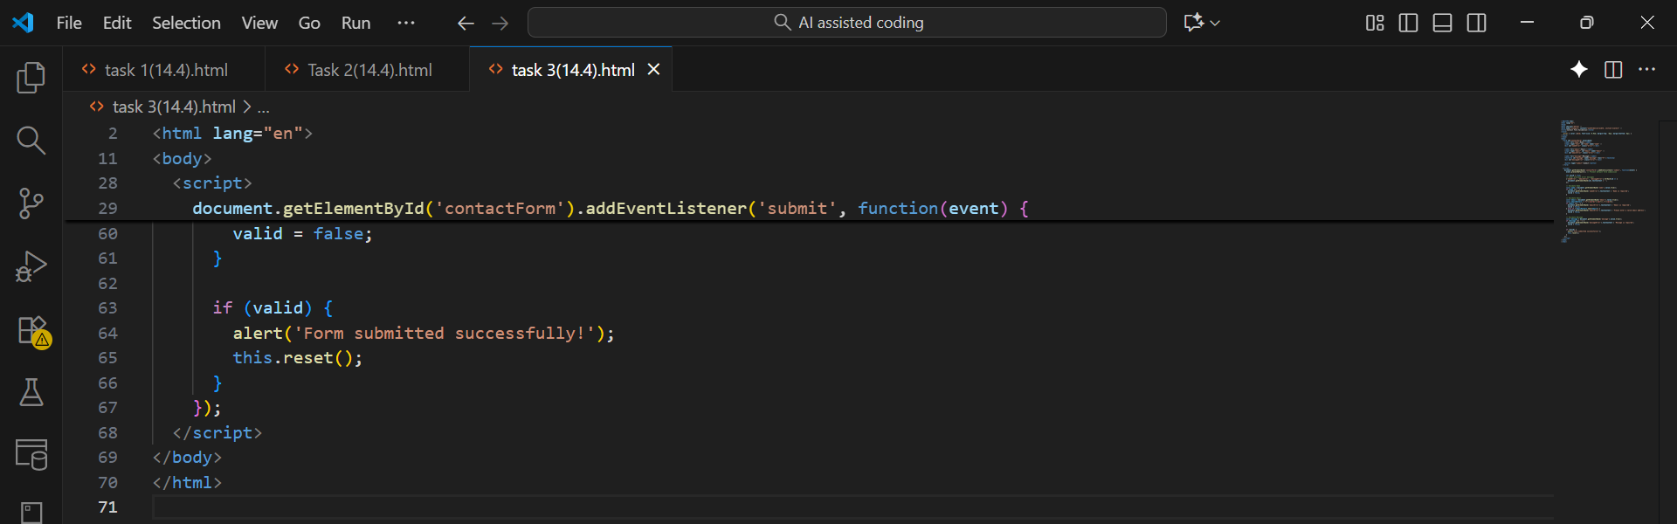
OUTPUT:

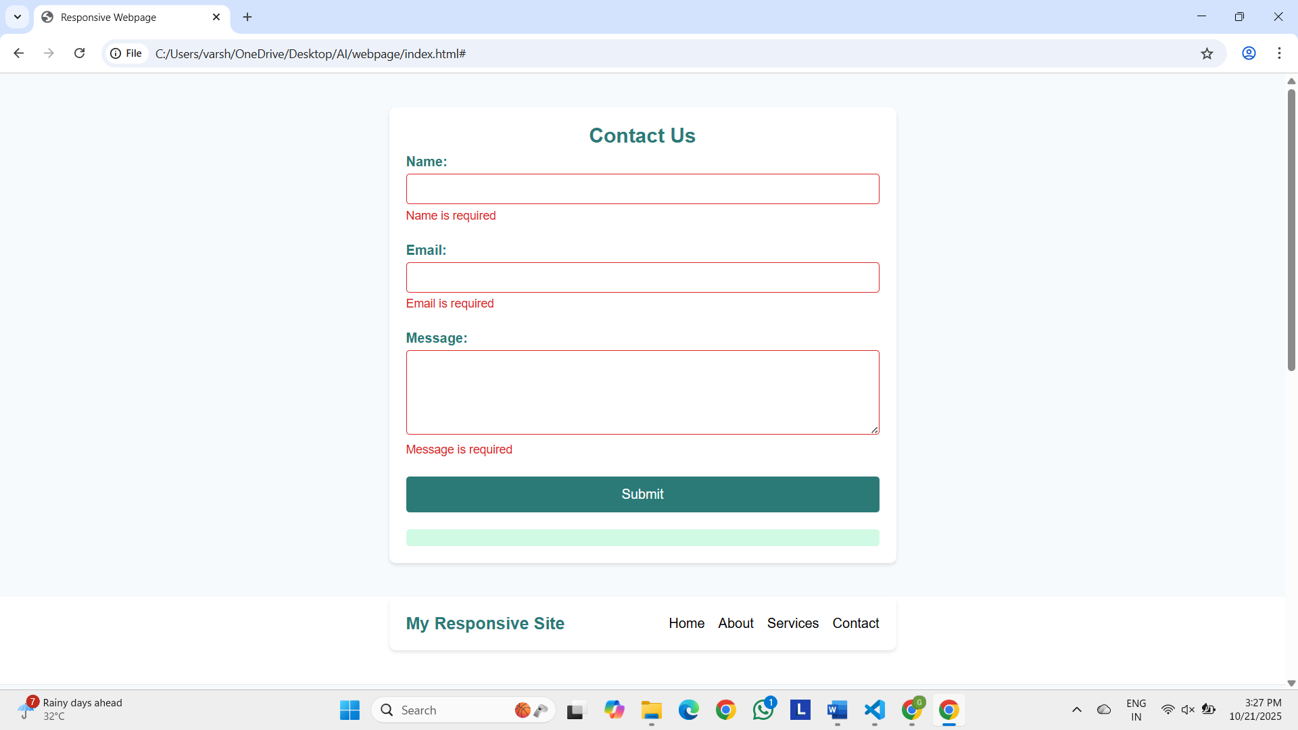
Observation:
The code creates a contact form with fields for name, email, and message, ensuring all are filled before submission. It checks that the email address follows a valid format and displays error messages right below the respective fields when invalid. When all inputs are valid, a success alert appears, and the form resets. The inline validation improves user experience by providing clear and immediate feedback.
Task-4:
Prompt:
Create a web page with a list of items that can be dynamically added or removed using JavaScript and buttons, updating instantly without page reload.
Code:

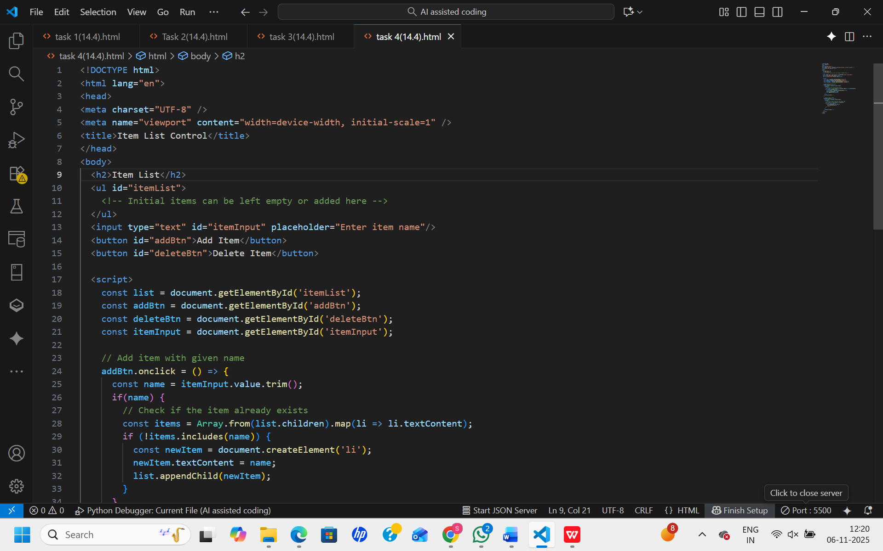

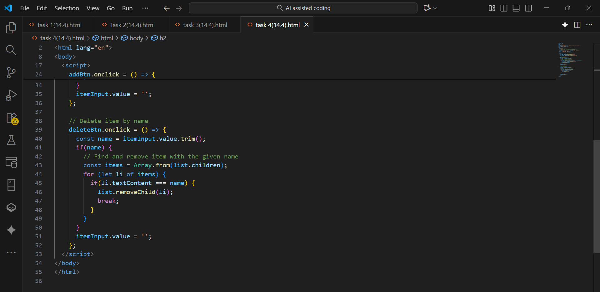
OUTPUT:

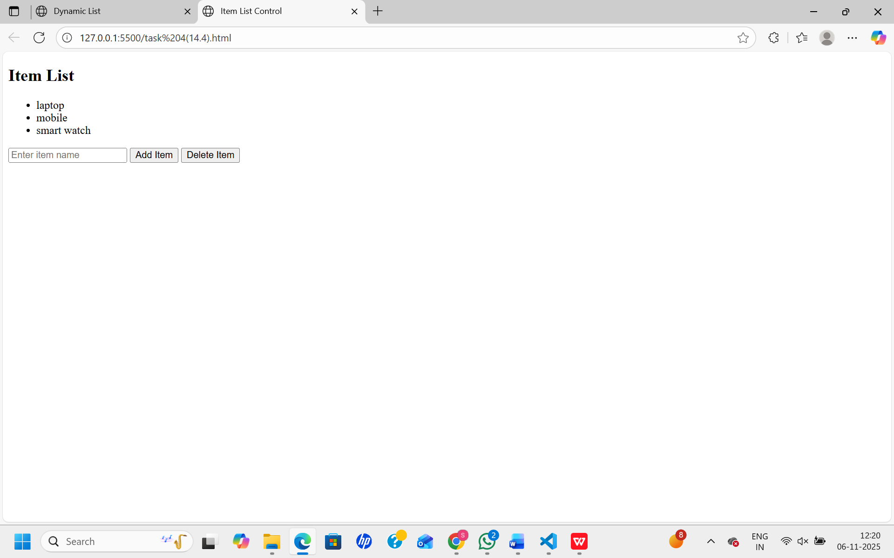
Observation:
The list on the page can be updated instantly by clicking the buttons. Adding creates a new item at the end, while removing deletes the last one. JavaScript handles all changes without reloading, making interactions smooth and fast. The code is simple and easy to use.
Task-5:
Prompt:
Create a styled modal popup that opens on button click with a semi-transparent overlay and can be closed by clicking the close button or overlay.
Code:

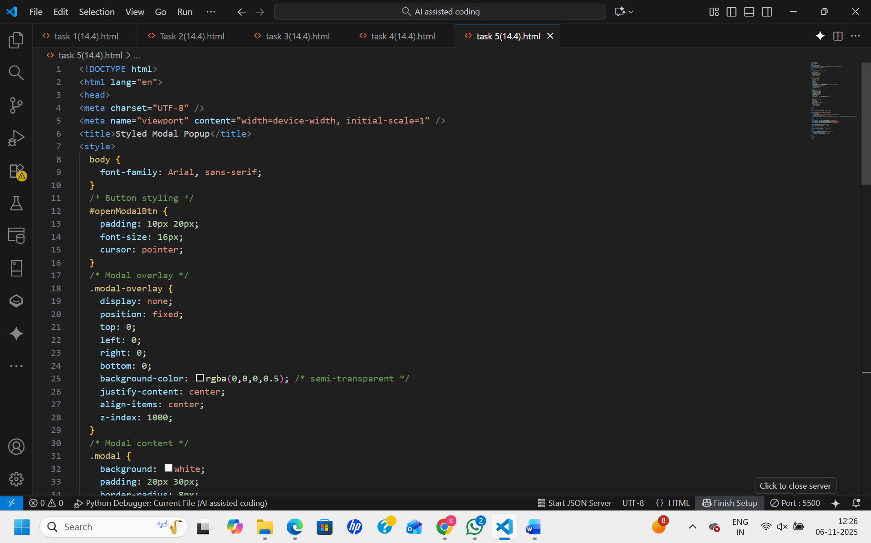

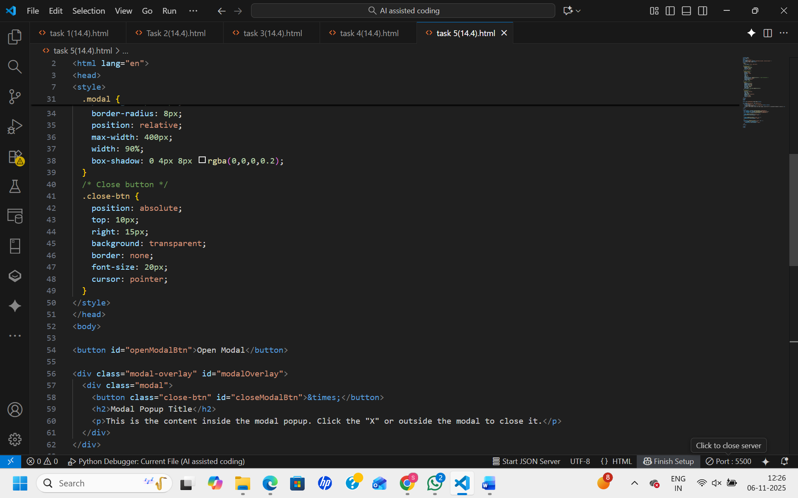

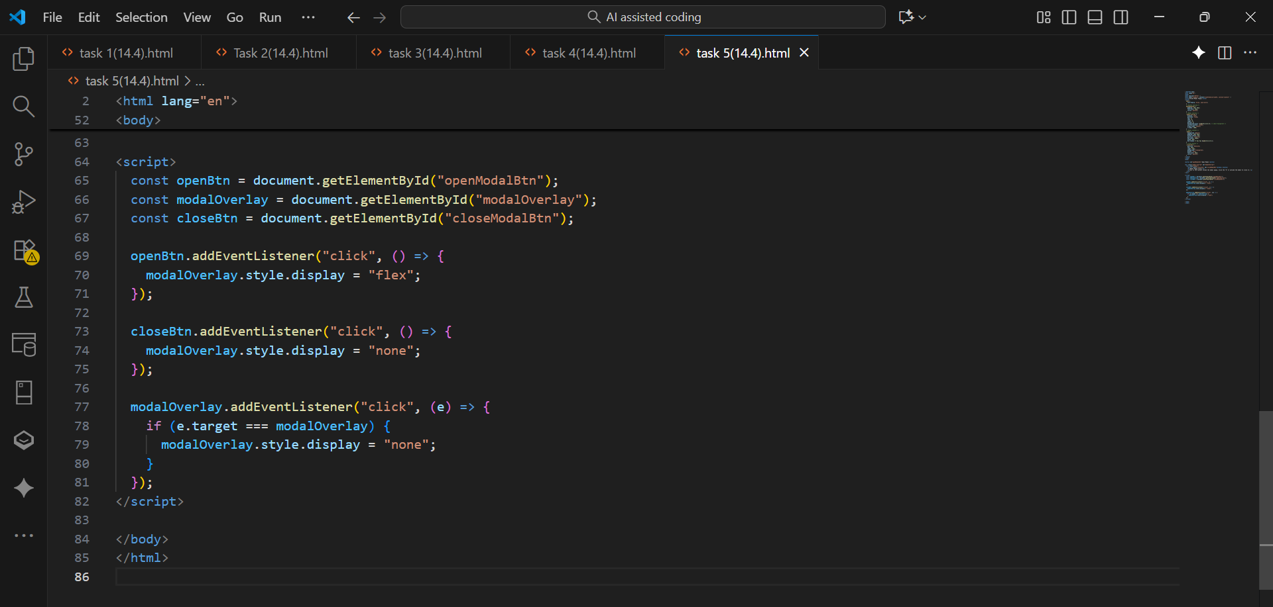
OUTPUT:

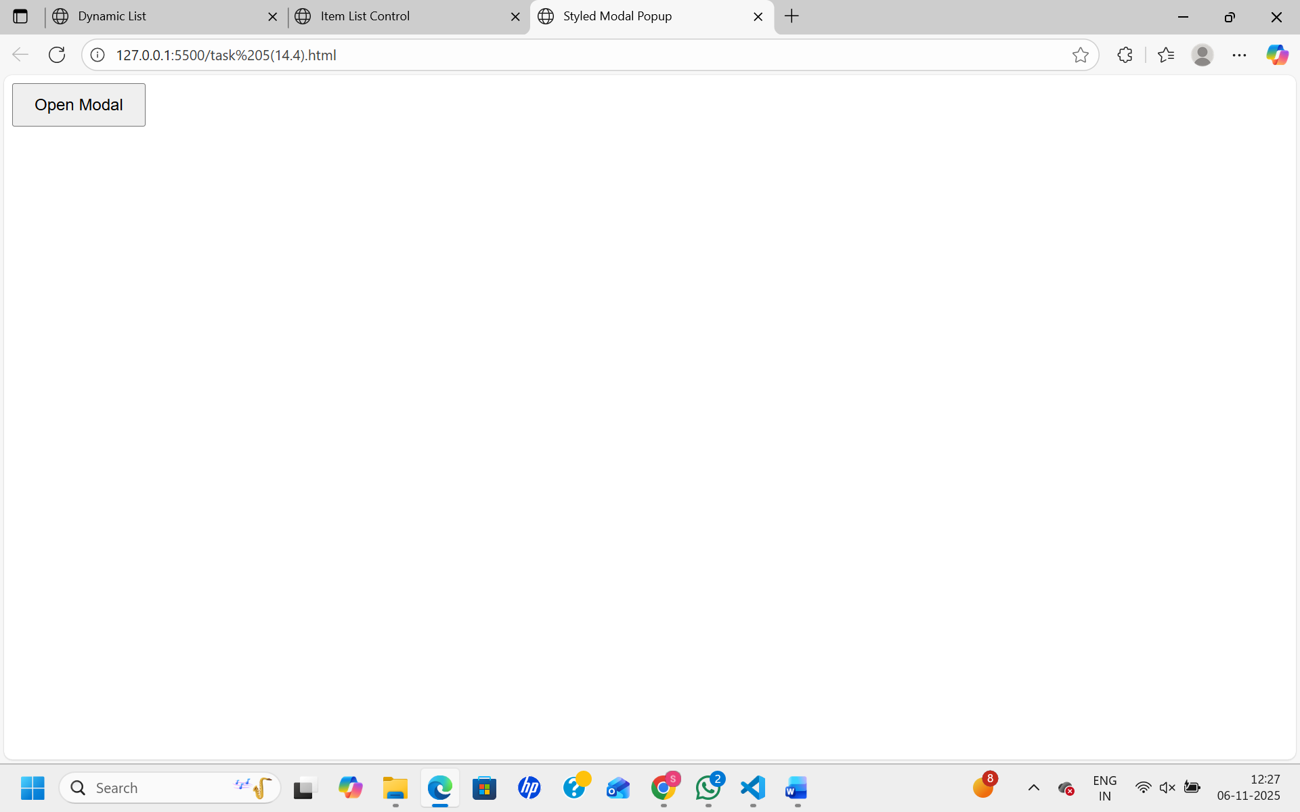

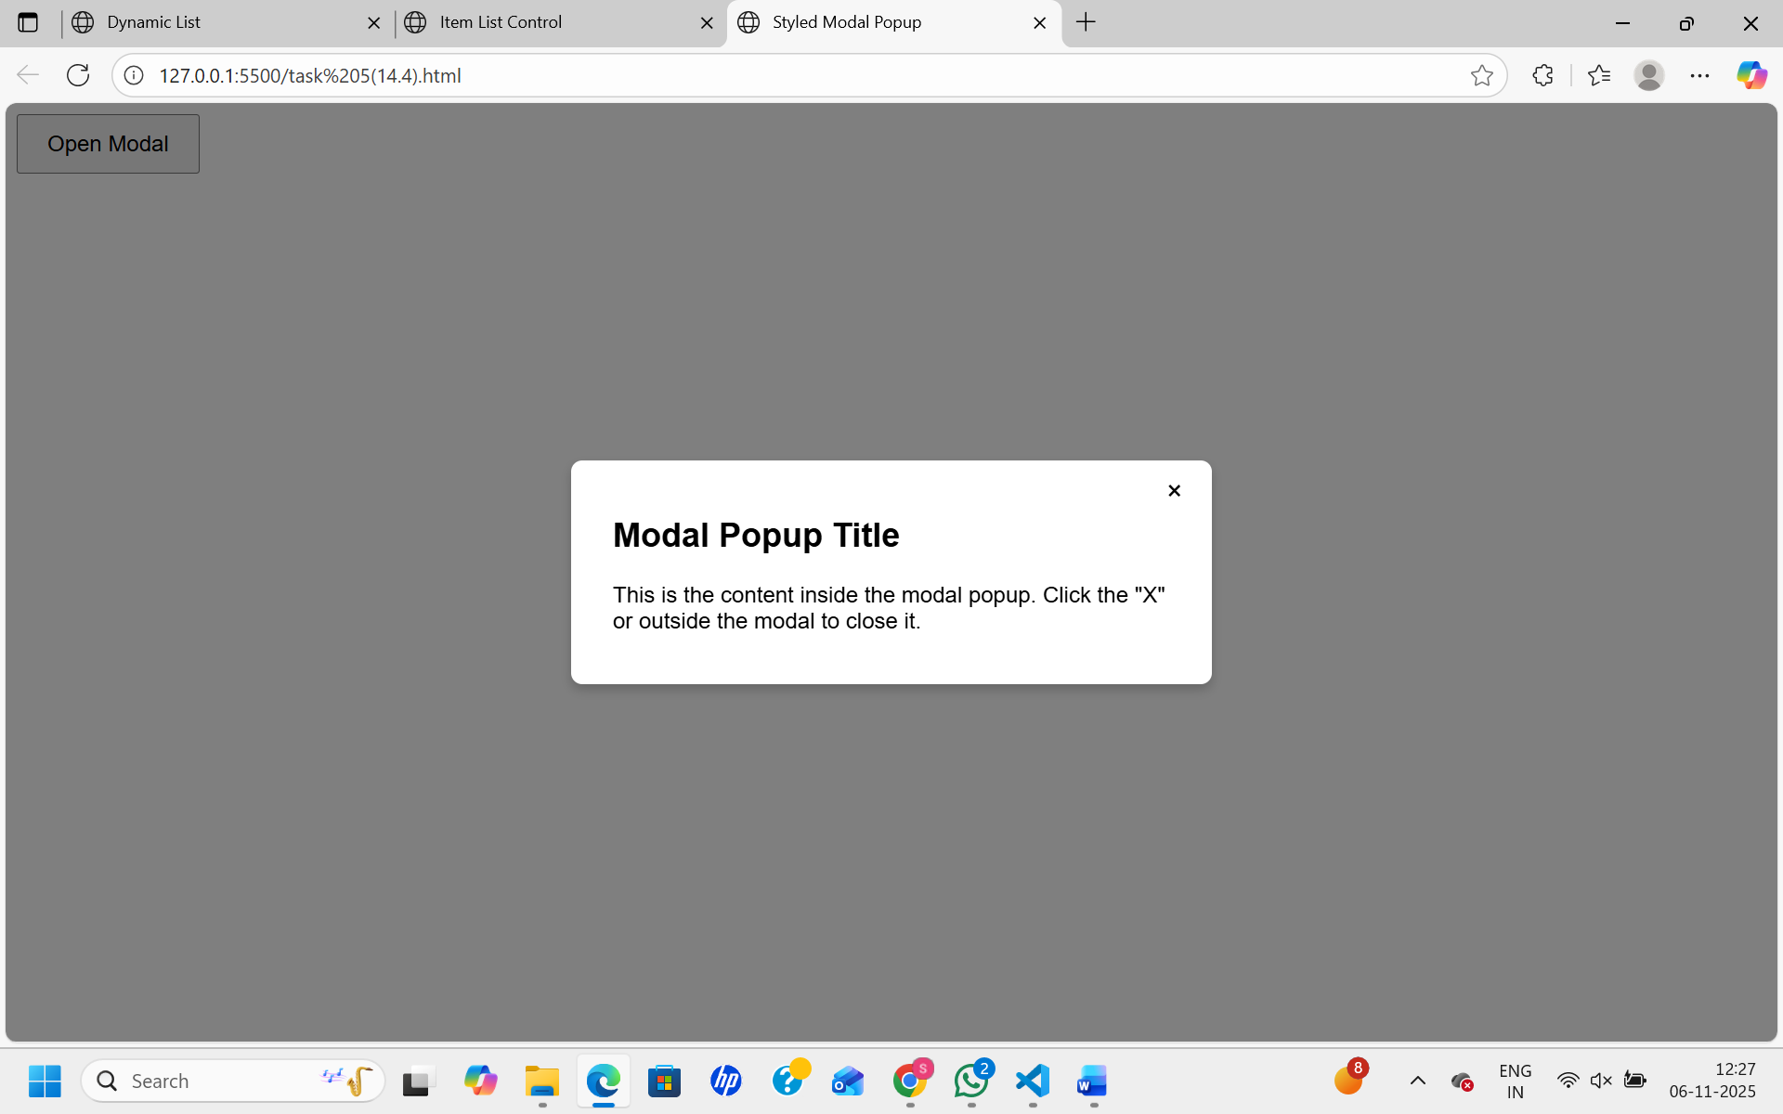
Observation:
The modal popup appears with a semi-transparent overlay when the button is clicked and closes by either clicking the close button or outside the modal area, providing a user-friendly and clear interface.

